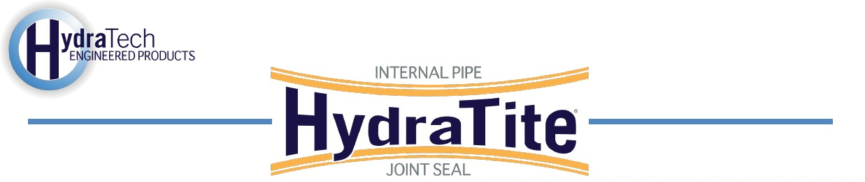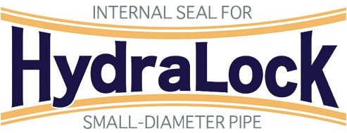

https://hydratechllc.com https://hydratechllc.com/services/field-services/

Market
Municipal

Challenge
A manhole rehabilitation project in Arizona involved multiple steps, including replacing the top
concrete cone, power washing the manhole walls, installing an FRP base liner, sealing the base liner to the existing pipe, and grouting behind the liner. The existing PVC pipe was 10 inches in diameter and sealing this pipe to the base liner would require an unmanned installation.

Engineered Solution
HydraLock was the chosen solution as it is a small diameter seal that is installed using
a packer.

Scope
The wastewater was bypassed for two hours and a packer was lowered into the pipe with the
HydraLock seal loaded on its back. The packer was positioned at the connection point between the existing PVC and the newly installed FRP base liner. The packer was expanded and the HydraLock locked in place. The process was completed a second time so that both the upstream and downstream connections were sealed.

Solution
In only two hours the HydraLock seal protected both the upstream and downstream
connections. The seal will make sure that the water does not form a pathway underneath the newly installed FRP base liner.

