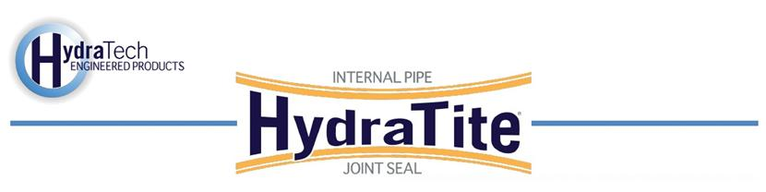
Market
DOT
Challenge
Two culverts were showing serious signs of degradation, especially at the joints. Spalling concrete had led to portions of pipe falling out near the joints. Almost every joint in these 60” and 72” culverts needed a repair that would not affect the traffic on the road above.
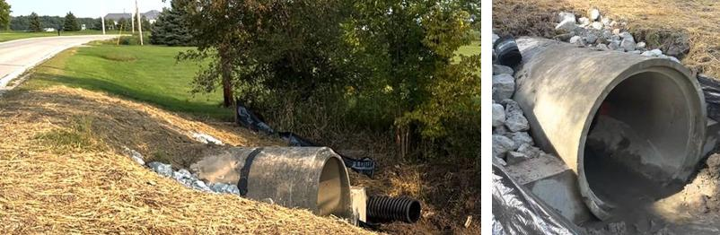
Engineered Solution
The DOT investigated various trenchless solutions that would not affect traffic and specified HydraTite Internal Joint Seals for the product’s long service life, and rapid installation at an economical price.
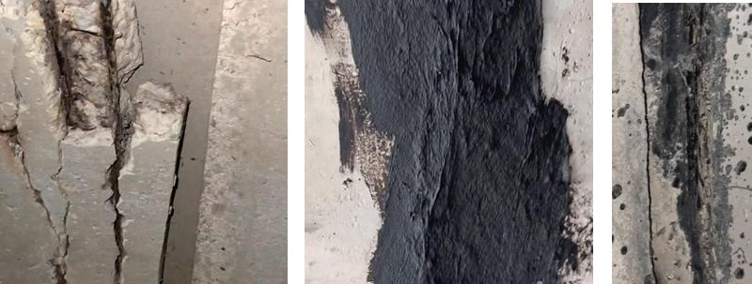

Scope
Both culverts were repaired following the same steps. Before the installation, damaged portions of pipe near the joints were smoothed out with concrete. Previous repairs that stretched beyond the joint were cut back closer to the joint to ensure the ribs of the HydraTite seal could effectively make contact with the host pipe’s surface. Then the 33 seals were installed, 17 of the standard-wide seals in the first 60” culvert and 1 of the double-wide, 4 of the extra-wide, and 11 of the standard-wide seals in the 72” culvert. The wider seals were utilized to cover larger separations formed by the missing portions of the pipe joint lip. The entire process was completed in 3 days.

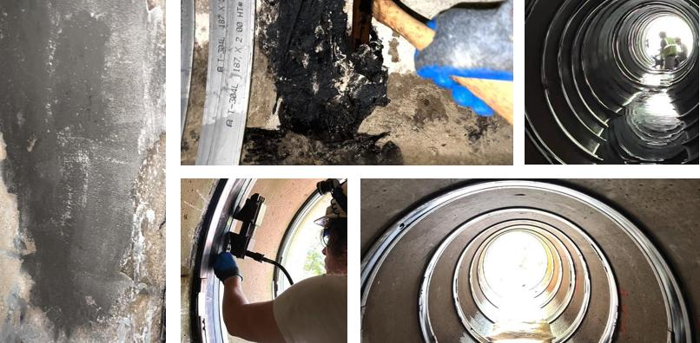

Solution
HydraTite proved to be a cost-effective means of rehabilitation that did not interfere with traffic and provided an economical and time-efficient repair that will protect the pipe for years to come.

HydraTech Engineered Products, LLC
HydraTech Field Services, LLC
10448 Chester Road Cincinnati, Ohio 45215 Phone: (513) 827-9169 Fax: (513) 8279171
https://hydratechllc.com
https://hydratechllc.com/services/field-services/

