

Market
Water & Utilities

Challenge
A county in New York discovered leaking joints in their 48” water main. This raised concerns of contamination and eventually sinkhole formation. The system was getting older and several other joints were identified as likely to fail soon. It was decided that four joints would be sealed in the first line, five joints in the second line, and one joint in the third line. The water main could not be shut down for an extended period as this would be an inconvenience for the public.

Engineered Solution
Extra-wide HydraTite Internal Pipe Joint Seals were ordered to eliminate the infiltration and exfiltration

Scope
Based on the limited time for installation, HydraTech broke the project into two phases.
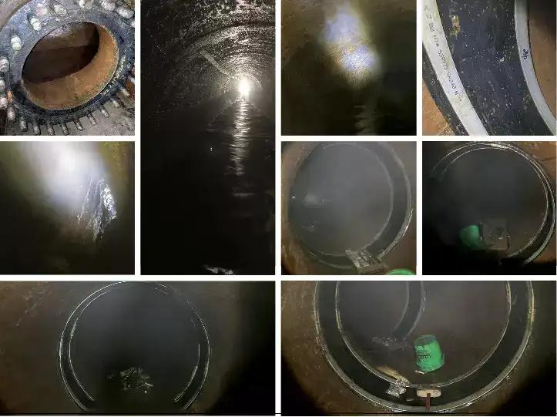

Phase One
During the first mobilization, water had collected in portions of the first pipeline that dipped down lower than the rest of the pipe. This was pumped out and HydraTech’s technicians navigated the twists and turns of the pipe to the most serious leak. Mineral build-up near the joint was cleared away with spackling knives to ensure a smooth sealing surface. The seal was installed and air-tested. Once this seal passed the air test, the crew made their way back out of the pipe. As they moved towards the exit they installed and air-tested three more seals. Once they climbed out of the pipe, it was closed and put back in use. In twelve hours the crew installed four seals.

Phase Two
During the second phase, the other two lines were worked on. Due to a previous surge in pressure, the second line had developed fissures near one of the compromised joints. This location required two seals installed right next to each other, one over the joint and one over the fissures. The crew started installing the five seals in the second line, but the third line was then shut down due to a decrease in water demand from those it supplied. The crew shifted to install the single seal in the third line and then returned to finish the second line’s five seals. Both lines were rehabilitated in only three days.

Solution
HydraTech’s crew worked within the limited window to rehabilitate the water main. The installation plan was adapted to fit the needs of the client and the HydraTite seals will protect the system from infiltration and exfiltration. This installation will help prevent contamination and sinkhole formation for a fraction of the cost of replacement and will last longer than grout.

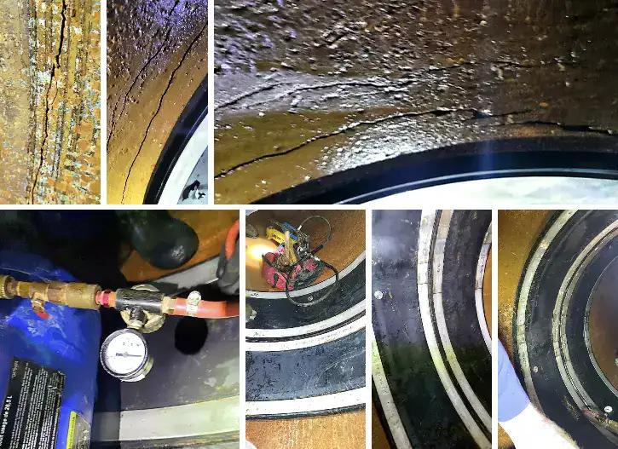

HydraTech Engineered Products, LLC
HydraTech Field Services, LLC
10448 Chester Road, Cincinnati, Ohio 45215 Phone: (513) 827-9169 Fax: (513) 827-9169
https://hydratechllc.com
https://hydratechllc.com/services/field-services/

