

Market:
Stormwater
Challenge:
A 72” storm drain in Texas had recently been installed but failed a pressure test. Replacing pipe that had just been installed was not an option and grouting the joints would not be a long-term solution. A permanent repair option was needed that could withstand the anticipated high head pressure once the pipes were put in service. A trenchless repair was required to ensure that the road above would not be disturbed.
Engineered Solution:
Standard-wide HydraTite Internal Pipe Joint Seals with three of the two-piece retaining bands was the chosen solution for this system. The additional retaining band was selected to address the expected high head pressure.
Scope:
Since this pipeline was recently installed, the interior surface of the pipe was in good condition and free of debris. There was minor joint separation, but none separated more than an inch. The rubber seals were placed at each of the joints so that the ribs made contact with the interior surface of the pipe on either side of the joint. Then two retaining bands were installed atop the rubber, putting pressure on the ribs. The third band was loosely constructed and positioned between the initial two bands. After that, the seals were each air tested. Finally, the third band was expanded and locked in place. Our crew of 3 installed 61 seals in 9 work days.

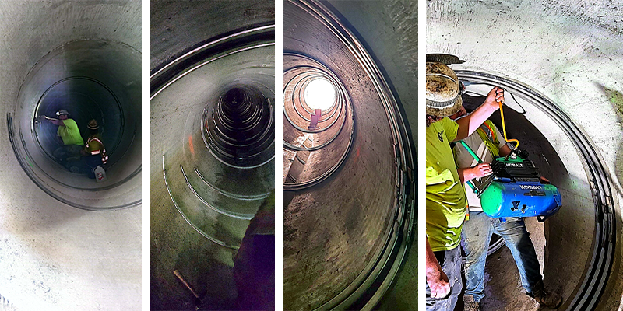
Solution:
Every joint in this storm drain was fortified against leaks in only 9 days. This trenchless installation did not disrupt the traveling public and will provide decades more protection compared to grout.

HydraTech Engineered Products, LLC
HydraTech Field Services, LLC
10448 Chester Road, Cincinnati, Ohio 45215 Phone: (513) 827-9169 Fax: (513) 827-9171 http://www.hydratechllc.com
https://hydratechllc.com/services/field-services/

