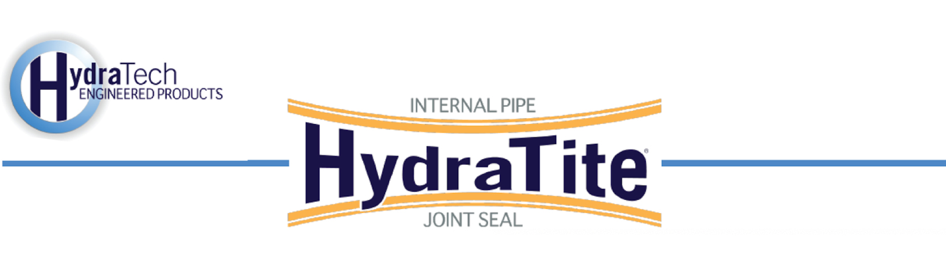

Market
Drinking Water

Challenge
Exfiltration was discovered in a joint in a d-shaped pipe that ran between two tanks. Due to the depth of the pipe and its position between the tanks, a trenchless solution was needed. A repair was required before the erosion from the leak compromised the system further.

Engineered Solution
An Extra-Wide HydraTite Seal with anchors was the chosen solution to eliminate the leak.

Scope
A crew of two people installed this custom-manufactured HydraTite seal in the pipe that was approximately 72” tall and wide. The rubber was positioned over the joint, and the stainless steel bands were then loosely placed over the rubber. Achor holes were then drilled along the edge of the rubber on each flat portion of the pipe’s interior surface. Anchors and hold-downs were then loosely positioned over the retaining bands. The retaining bands were expanded and locked in place. Then the hold-downs were tightened down onto the seal. Finally, The seal was air-tested to ensure that the leak had been eliminated. The entire process was completed in a single day.

Solution
The repair was completed at a fraction of the cost associated with other options. The HydraTite seal eliminated the leak very quickly and the connected tanks were undisturbed during this process.

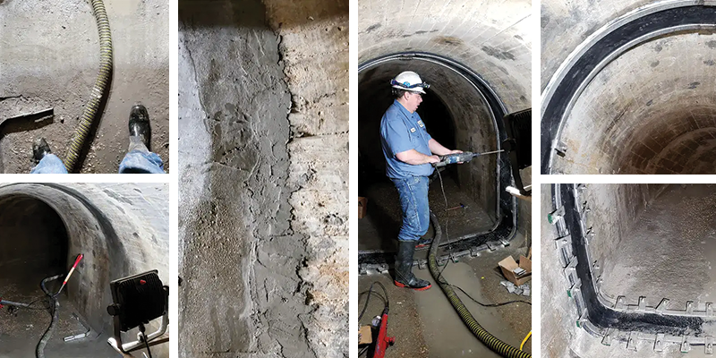

HydraTech Engineered Products, LLC
HydraTech Field Services, LLC
10448 Chester Road, Cincinnati, Ohio 45215 Phone: (513) 827-9169 Fax: (513) 827-9171 http://www.hydratechllc.com
https://hydratechllc.com/services/field-services/

