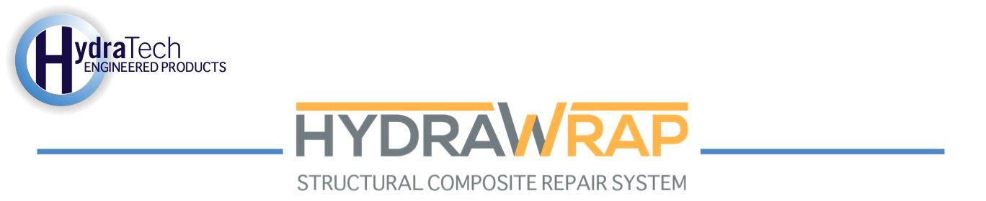

Market:
Water & Utilities
Challenge:
A municipal pump station discovered a cluster of pinholes in an 18” FRP pipe. A repair was needed that could be applied quickly and withstand the corrosive properties of the pipe's contents.
Engineered Solution:
They chose to apply the HydraWrap Structural Composite Repair System. They were supplied 12” wide fabric and acid-resistant epoxy.
Scope:
The pipe was briefly shut down to stop the active leak. First, the repair area’s surface was cleaned. For pipes with smooth surfaces, such as FRP pipes like this, PVC, and HDPE, extra attention is needed to create a textured surface. To extend the service life of this repair, the surface of the pipe was abraded to promote good bond strength. This newly created mechanical profile extended 3” beyond the compromised portion of the pipe. Once the pipe’s surface, was clean, dry, textured, and even, the primer epoxy was applied. Next, the carbon fiber fabric was saturated with wet-out epoxy. Finally, two layers of fabric were wrapped around the repair area. The entire process was completed in a single day, limiting the necessary downtime.
Solution:
HydraWrap proved to be a simple solution that the client was able to apply quickly and allowed the pipe to be put back in service with limited downtime. The entire project was completed at a fraction of the cost of replacement.
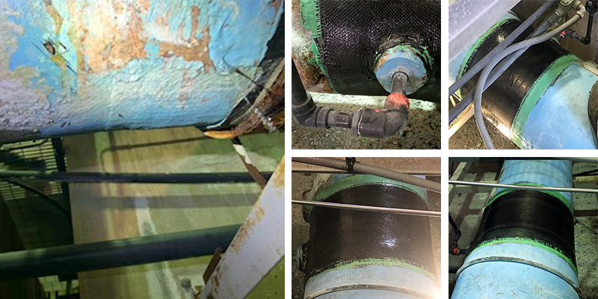
HydraTech Engineered Products, LLC
10448 Chester Road, Cincinnati, Ohio 45215
Phone: (513) 827-9169 Fax: (513) 827-9171
http://www.hydratechllc.com

