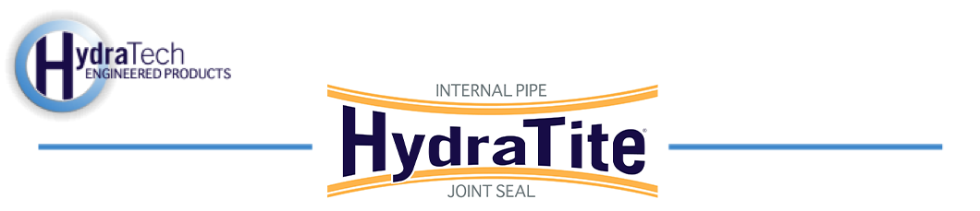

Market:
Drinking Water
Challenge:
Inspection of a cast-in-place conduit from the early 1920s revealed 13 joints in poor condition, three of which had developed active leaks. This pipe was approximately 90" in diameter and was not perfectly concentric, incorporating a slightly flattened invert. A solution was needed quickly, that would cause minimal disturbance and downtime.
Engineered Solution:
13 Extra-Wide HydraTite Seals were chosen as the solution to eliminate the leaks.
Scope:
First, the water was pumped out. Next, the surface of the pipe had to be prepared near the pipe. Debris was cleared away and concrete was used to smooth out the irregularities of this old pipe's interior surface. Each seal was installed and then air tested. Some air tests revealed additional surface prep was required. These seals were deconstructed and more concrete was applied. The small crew had installed 13 seals that each passed the air test in only 8 days on site.

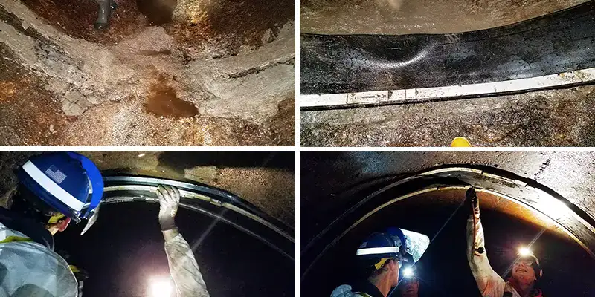
Solution:
HydraTite provided a quick solution that was more targeted than lining, more long-lasting than grout, and less disruptive compared to dig and replace. These joints will be protected against infiltration and HydraTite will help prevent the formation of sinkholes.

HydraTech Engineered Products, LLC
HydraTech Field Services, LLC
10448 Chester Road, Cincinnati, Ohio 45215 Phone: (513) 827-9169 Fax: (513) 827-9171 http://www.hydratechllc.com
https://hydratechllc.com/services/field-services/

