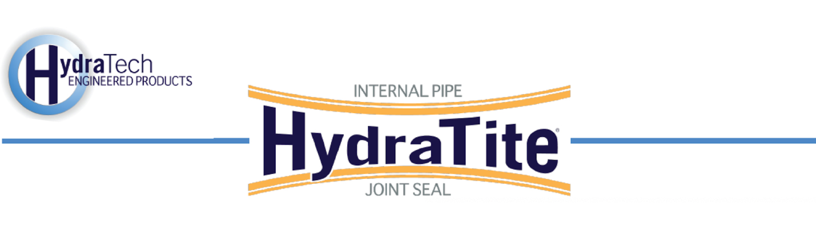

Market
Water & Utilities

Challenge
A water treatment plant discovered leaking joints in their influent pipes and basins that were part of the filtered water conduit. These systems were structurally sound but compromised at the joints. A targeted repair that could be installed without the system being dewatered was preferable.

Engineered Solution
HydraTite Internal Pipe Joints Seals were the chosen solution to eliminate the leaks. The box-shaped seals were to be installed with steel corner forms, sealant, and anchors.

Scope
Two divers installed five seals and each seal was installed in 1 to 2 days each. 4 of the seals were installed without the pipe being dewatered. The interior surface of the pipe near the joints was prepared for installation by smoothing out all irregularities. In a couple of instances, the walls of the basin were sloped and steel spacers were used to plumb up the seal. The rubber was positioned over the joints. The retaining bands were then expanded, locking the rubber in place. The box seals required corner forms to be put in place to assist in the rubber’s transition over the 90-degree corners. Then sealant was applied to the edge of the corner forms. Anchors were drilled for the box seals as well. 2 of the 60” extra-wide circular seals were installed. The basins each required different sized seals. A 127” by 73” extra-wide seal, a 108” by 73” double-wide seal, and a 108” by 28” double-wide seal were all installed.

Solution
HydraTech custom-manufactured seals that will provide a long-term repair for these 5 joints. They were installed quickly and most were installed underwater. The leaks were eliminated and the facility has had success using this repair method on other joints that were not in the scope of this project as well.

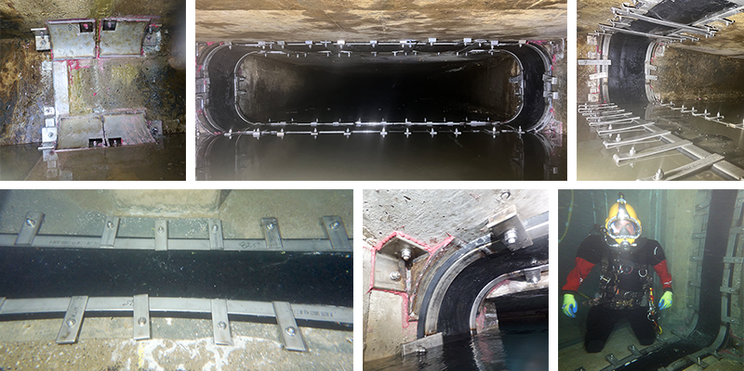

HydraTech Engineered Products, LLC
HydraTech Field Services, LLC
10448 Chester Road, Cincinnati, Ohio 45215 Phone: (513) 827-9169 Fax: (513) 827-9171 http://www.hydratechllc.com
https://hydratechllc.com/services/field-services/

