

Market:
Stormwater
Challenge:
A newly installed storm drain sump that ran along the side of a levee failed its pressure test. Infiltration at the joints threatened the integrity of this box-shaped concrete pipe. A targeted repair was needed, rather than replace the newly installed system.
Engineered Solution:
Standard-wide HydraTite Internal Pipe Joint Seals with anchors and hold-downs were the selected method to rehabilitate these joints without excavation.
Scope:
One crew member positioned the materials near the joints and loosely constructed the retaining bands. The two other crew members installed the seals. First, the holes for the anchors were drilled on either side of the joints. Next, the debris from the drilling was brushed away and the anchors were driven into each hole. Then the rubber was positioned over the joint and the retaining bands worked inside the rubber’s designated channels. Butyl rubber was applied to the corners to aid the seal’s rubber in the transition over the corner. After that, the anchor plates were loosely installed so they lay atop the retaining bands. The retaining bands were then brought to pressure and the hold-downs were tightened against the bands. Each seal was air tested and if the anchors protruded beyond the hold-downs, they were trimmed back. The crew of 3 installed 17 seals in 8 onsite days.

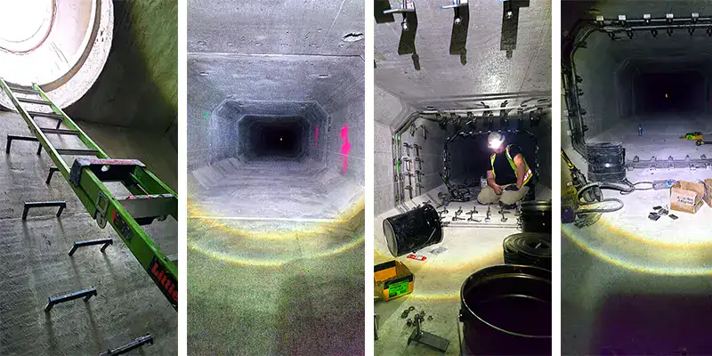
Solution:
This box-shaped storm drain sump was rehabilitated quickly without needing to be dug up. The infiltration was eliminated and these joints will be safeguarded from leaks for decades.

HydraTech Engineered Products, LLC
HydraTech Field Services, LLC
10448 Chester Road, Cincinnati, Ohio 45215 Phone: (513) 827-9169 Fax: (513) 827-9171 http://www.hydratechllc.com
https://hydratechllc.com/services/field-services/

