

Market:
Drinking Water
Challenge:
A new school was being built in Iowa atop pipes laid in 1937. The expected heavier use of the water main prompted the inspection of two aging 30” cast iron pipelines. Nearly 100 joints were determined as points of concern. The project owners wanted to fortify the existing pipes against infiltration without excavation.
Engineered Solution:
Standard-wide HydraTite Internal Pipe Joint Seals were the selected method to rehabilitate these joints without excavation.
Scope:
The project was completed in two phases. One at a time, each pipe was shut down, repaired, and then put back in use. Due to the age of the pipe, the interior had developed an extensive amount of scaling. Concrete mortar had also been applied to several joints as well. The interior surface of the pipe had to be cleared of both scaling and concrete mortar before installation to ensure that HydraTite could seal properly. 46 seals were installed in one pipeline and 49 seals were installed in the other for a total of 95 seals installed. These joints were cleaned, sealed, and air tested in just over two weeks.

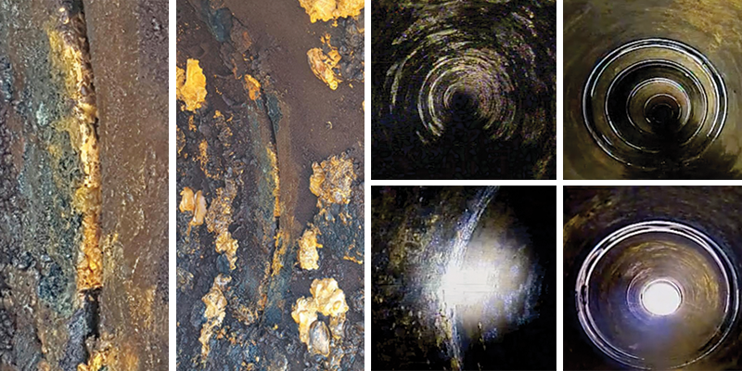
Solution:
In very little time, these two pipelines were fortified against infiltration and prepared for the anticipated increase in use. These nearly century-old pipes were rehabilitated without excavation and at a fraction of the cost of replacement.

HydraTech Engineered Products, LLC
HydraTech Field Services, LLC
10448 Chester Road, Cincinnati, Ohio 45215 Phone: (513) 827-9169 Fax: (513) 827-9171 http://www.hydratechllc.com
https://hydratechllc.com/services/field-services/

