

Market
Sanitary Sewer

Challenge
A water pollution district was aware that their underground pipe was old enough to expect problems and they began inspecting their pipes with cameras. Their concerns were well founded and they discovered infiltration. They needed a trenchless solution that could be installed without the pipes being taken out of service.

Engineered Solution
Extra-wide HydraTite Internal Pipe Joints Seals with three of the two-piece retaining bands were the chosen repair method to eliminate the leaks.

Scope
This project saw the installation of 12 HydraTite seals, all in the same pipeline but far enough apart to necessitate entry through different manholes. Due to the hazardous contents of the pipe, additional safety requirements were in place compared to other jobs. Proper PPE, air monitoring, full face respirators, and a wash-down station were some of the precautions that were needed. Another complicating factor was the heavy flow of the pipe which the crew had to install in. Despite the age of the pipe, the interior surface of the pipe was in fairly good condition and required minimal surface prep for the seal installation. Once the interior surface was ready, the rubber was placed over the joint. Next, the two outer retaining bands were positioned, expanded, and locked in place with a wedge. Finally, a third retaining band was positioned atop the rubber so that it was between the previously installed bands. Technicians also ensured that this final band would put pressure on the host pipe and not expand into the joint. Once this band was in the right spot, it was brought to pressure and locked in place. A crew of three people successfully installed the seals in only 8 onsite days.

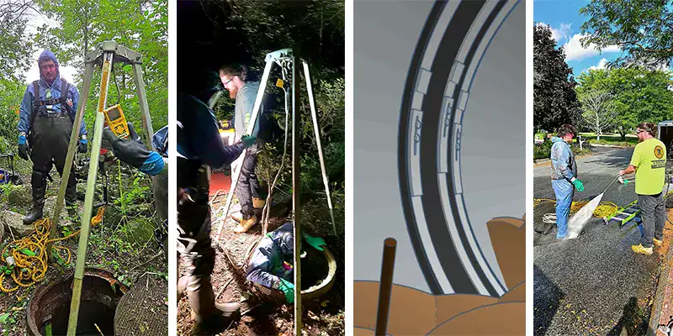

Solution
HydraTech’s small crew was able to seal these 12 joints quickly, eliminating infiltration. This long-term repair was put in place without the pipe being taken out of service.

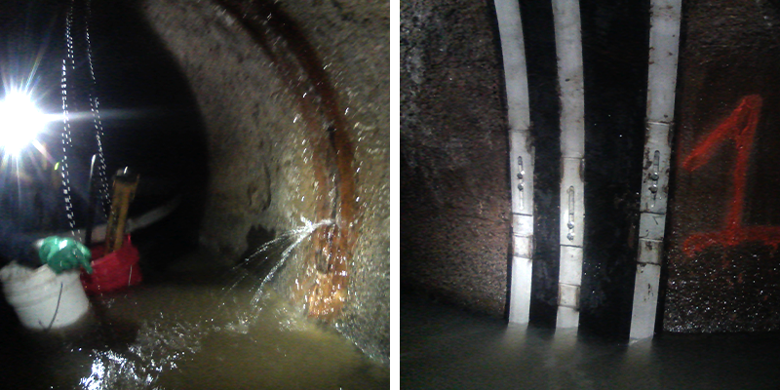

HydraTech Engineered Products, LLC
HydraTech Field Services, LLC
10448 Chester Road, Cincinnati, Ohio 45215 Phone: (513) 827-9169 Fax: (513) 827-9171 http://www.hydratechllc.com
https://hydratechllc.com/services/field-services/

