

Market:
DOT
Challenge:
Three culverts had soil infiltrating their joints. Preventative maintenance was needed to avoid the formation of sinkholes. A targeted repair was preferable to replacement to avoid disrupting the above traffic.
Engineered Solution:
HydraTite Internal Pipe Joints Seals were chosen as a targeted and trenchless repair.
Scope:
The culverts required seals manufactured with 47.5”, 48”, and 54” diameters. One technician worked for three days to install nine seals over three culvert locations. Most joints were repaired with extra-wide seals and double-wide seals were installed over joints with more severe offset and separation. Minor debris was cleared away from the joints. In the corrugated pipe, butyl rubber was used to fill the corrugation prior to installation. The EPDM rubber was positioned over the joints and then the stainless steel retaining bands were used to lock the seal in place.

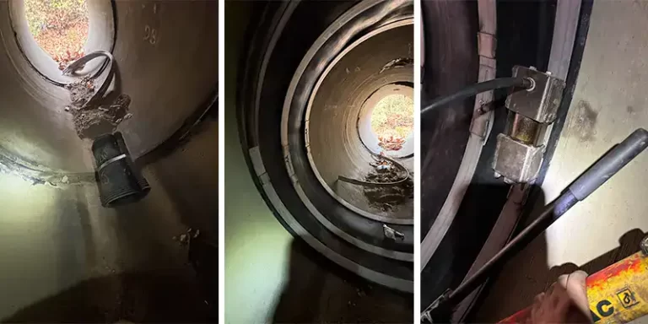
Solution:
HydraTite was successful in eliminating soil infiltration in the repaired joints without needing to dig down to the pipes. The repair was quickly implemented and will last much longer than grout.

HydraTech Engineered Products, LLC
HydraTech Field Services, LLC
10448 Chester Road, Cincinnati, Ohio 45215 Phone: (513) 827-9169 Fax: (513) 827-9171 http://www.hydratechllc.com
https://hydratechllc.com/services/field-services/

