
Market
Municipality

Challenge
A city in western Ohio was dealing with repeated washouts and sinkholes caused by infiltration through leaking joints in a 36-inch reinforced concrete storm drain. Multiple grout repair attempts over two-years failed to stop the leaks, prompting the city to seek a permanent, cost-effective solution. The storm drain ran under an active road. To avoid disruption of the traveling public, the city needed a trenchless solution.

Engineered Solution
HydraTite® Internal Pipe Joint Seals were selected as the no-dig solution to repair the failing joints permanently.

Scope
The project was completed by HydraTech technicians without any excavation or surface disruption. Over the course of the work, all the joints were cleaned, prepped, and sealed internally, ensuring long-term protection. The four joints that were more severely deteriorated were sealed with extra-wide HydraTite seals with three of the one-piece retaining bands. The other three joints that were less degraded were sealed with three standard-wide HydraTite seals with two of the one-piece retaining bands.

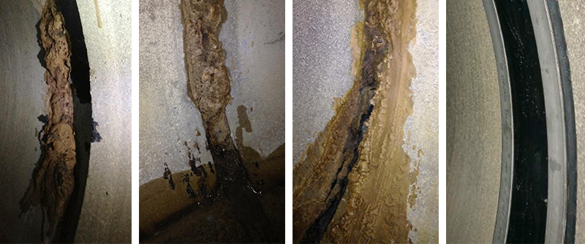

Solution
The HydraTite® seals successfully eliminated infiltration, preventing further washouts and sinkholes. City officials and residents were pleased with the results, and the client now plans to specify HydraTite® seals for future RCP repairs instead of grout.

HydraTech Engineered Products, LLC
HydraTech Field Services, LLC
10448 Chester Road, Cincinnati, Ohio 45215 Phone: (513) 827-9169 Fax: (513) 827-9171
http://www.hydratechllc.com
https://www.hydratechfs.com

