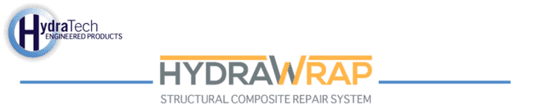

Market:
Hydroelectric Plant
Challenge:
The challenge was to structurally reinforce fourteen defected areas of piping at the penetrations to the bulkheads.
Engineered Solution:
The solution utilized the HydraWrap® Structural Composite Repair System to reinforce the pipe wall and penetrations.
Scope:
The piping had been in operation for over 30 years and had several degraded areas. The project included pipe replacement and structural repairs to the cooling water pipe system. Pipe replacements were performed on accessible piping and HydraWrap® pipe wraps were used at pipe penetrations.
Solution:
The HydraWrap® system was installed per HydraTech procedure on both 8” and 10” pipe penetrations. The surface was prepared according to NACE specifications, and the HydraWrap® system was designed according to ASME PCC-2 to restore the pipe wall to design conditions.
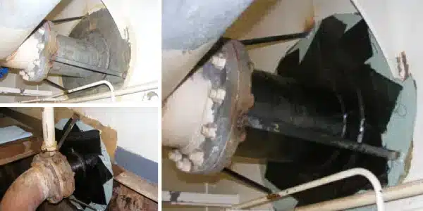

HydraTech Engineered Products, LLC
HydraTech Field Services, LLC
10448 Chester Road, Cincinnati, Ohio 45215 Phone: (513) 827-9169 Fax: (513) 827-9171 http://www.hydratechllc.com
https://www.hydratechfs.com

