

Market:
Power Generation
Challenge:
A power generation facility in Kansas identified structural concerns on two 10-inch-diameter cast-iron cooling water supply pipes. The pipes, located just before isolation valves and adjacent to a concrete bulkhead, exhibited deterioration along critical sections. Conventional replacement would have required prolonged outages, significant excavation, and high cost—none of which were feasible for the facility’s operations.
Engineered Solution:
HydraTech recommended HydraWrap®, a fiber-reinforced polymer (FRP) composite system designed for structural rehabilitation. For an additional layer of protection and long-term durability, a topcoat was also specified.
Scope:
HydraTech supplied the HydraWrap materials and supervised the installation onsite, ensuring proper mixing, wet-out, and application procedures. First, the cast iron substrate’s surface was cleaned in accordance with SSPC SP-2/SP-3 standards. Once both locations had their surface prepared, primer epoxy was mixed and applied to the substrate. Next, the carbon fiber was saturated with wet-out resin, and the pipe was circumferentially wrapped. Eight inches were covered on the top of the pipe and four inches on its bottom, covering the bulkhead to the valve. Four complete circumferential wraps with 2-inch overlap ensured even stress distribution and full structural reinforcement. The installation was completed in a single day, minimizing downtime and disruption to plant operations.
Solution:
The HydraWrap® system successfully reinforced the two deteriorating cooling water pipes, restoring their structural integrity without the need for costly replacement. The HydraWrap system will protect this section of pipe from corrosion despite the high-moisture environment. The client received a structurally sound, corrosion-resistant solution that extended the service life of the pipes, safeguarded plant reliability, and demonstrated the value of trenchless composite repair technologies in critical infrastructure.
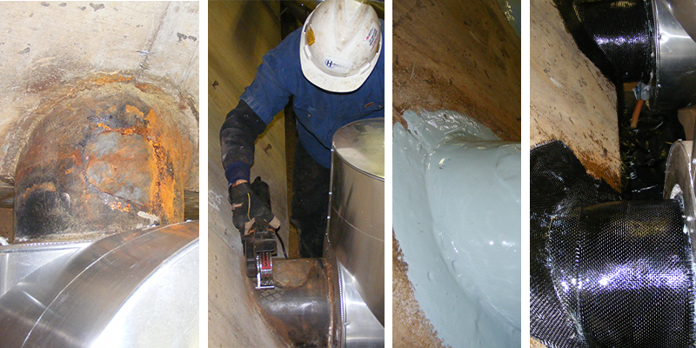

HydraTech Engineered Products, LLC
HydraTech Field Services, LLC
10448 Chester Road, Cincinnati, Ohio 45215 Phone: (513) 827-9169 Fax: (513) 827-9171 http://www.hydratechllc.com
https://www.hydratechfs.com

